set 1:
short question (2 marks):
- What is vanishing gradient problem?
- What is tensor in linear algebra? Give example.
- What is Dimension Reduction? Write the name of two methods of Dimension Reduction.
- What happens if the learning rate is too high or too low? Explain with figure.
- What is data normalization? Write the name of different techniques to achieve Data normalization.
- What is activation function? Give some examples of activation functions.
- Write some application of Deep learning.
short question (2.5 marks):
- What is the differences between ANN, CNN & rnn
- What is the differences between Dense and Sparse features in dataset?
- What is the differences between Batch Gradient Descent and Stochastic Batch Gradient Descent?
- What is Bias and Variance? What is the scenario of Bias and Variance on Model Overfitting and Underfitting?
short question (3 marks):
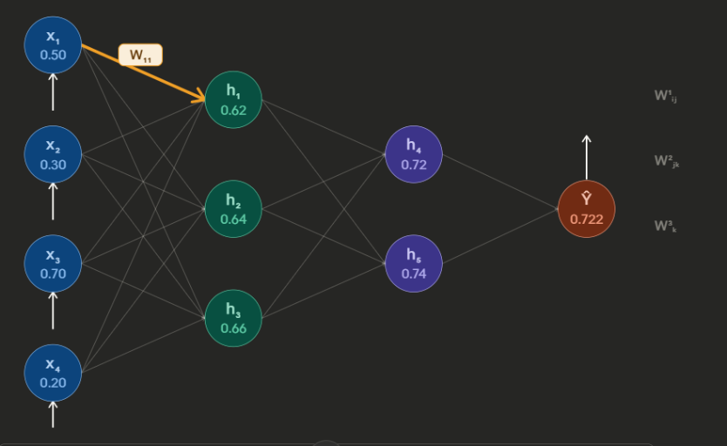

1.Explain the figure properly.
Assume Y Y’. Write the formula for update W11 by using chain rule equation. How will you get Y = Y’? explain your answer.
- How does CNN works? Explain with proper diagram.
- Describe the architecture of LSTM with proper diagram.
- What is perceptron? Write the perceptron learning algorithm. Explain the geometric view of perceptron.

set 2
short question (2 marks):
- What are the main applications of deep learning?
- What is data normalization? Write the name of different techniques to achieve Data normalization.
- How to remove Vanishing Gradient Problem?
- Write three differences between ANN, CNN & rnn.
- What are Global Minima and Local Minima?
- When we calculate mean squared error(mse) and binary cross entropy? write the equations of these loss function.
- Write the equation for ReLU activation function. Give two advantages of ReLU activation function.

short question (2.5 marks):
- Describe PCA(Principle Component Analysis) with an example.
- What is Saturating Function? Explain it by two activation functions.
- Explain Adagrad Optimizer.
- Assume you have a neuron with two inputs X = [3,7] that uses both the ReLU and Sigmoid activation functions separately. The neuron has the following parameters:

- Weights = [0.4, 0.6]
- Bias = 0.2
Calculate the output of the neuron during the feedforward process.
question (5 marks):
- How does CNN work? Explain with proper diagram.
- Describe the architecture of LSTM with proper diagram.
- What is perceptron? Write the perceptron learning algorithm. Explain the geometric view of perceptron.

